

Hope in Sri Lanka supports orphanages, neglected, abandoned and orphaned children in Sri Lanka. - They rely entirely on donations to provide help in housing, feeding and caring for children. Hope in Sri Lanka is a charity set up to bring emotional support to trauma affected children and families. The work was initiated in response to the Tsunami in December 2004
ROSSENDALE METHODIST CIRCUIT
WALK FOR ‘HOPE IN SRI LANKA’
A 90 MINUTE WALK OVER THE HILLS AROUND NEWCHURCH
FRIDAY 21ST OF JUNE
LEAVES NEWCHURCH METHODIST, TURNPIKE AT 6.30PM
(PLEASE ARRIVE BY 6.15PM TO REGISTER)
FOLLOWED BY REFRESHMENTS BACK AT CHURCH
SPONSOR FORMS AVAILABLE/DONATIONS WELCOME

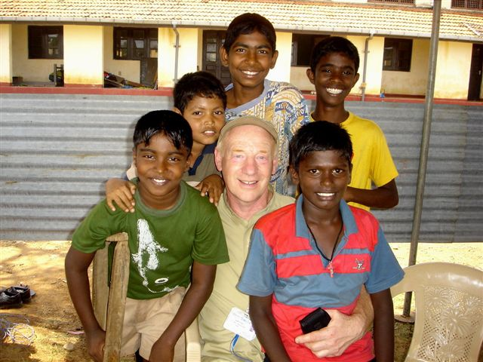
FOR THOSE WHO PREFER NOT TO WALK ….COME AND JOIN US AT NEWCHURCH AT 7.30PM TO FIND OUT MORE ABOUT THE CHARITY, ENJOY THE REFRESHMENTS AND WELCOME THE WALKERS BACK.
THE WALK WILL BE LED BY RON SUTHERS AND FRAN ASPINALL. DON’T FORGET TO WEAR SUITABLE CLOTHING AND FOOTWEAR!

